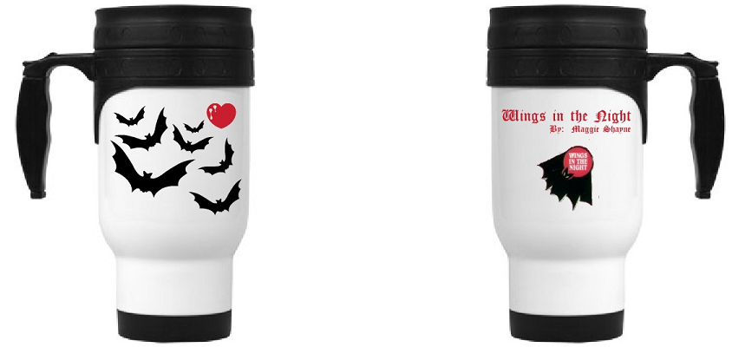
Wings in the Night Travel Mug
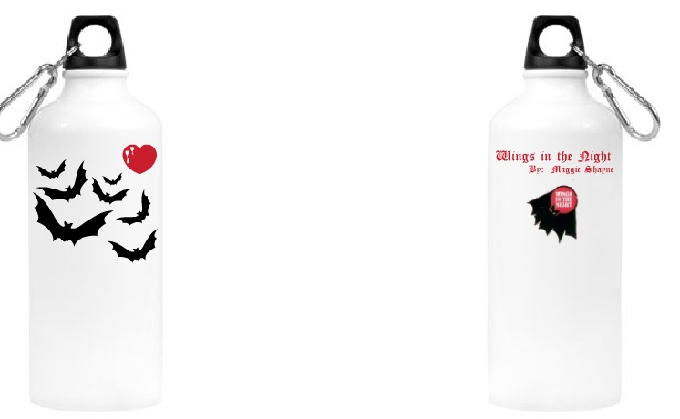
Wings in the Night Water Bottle
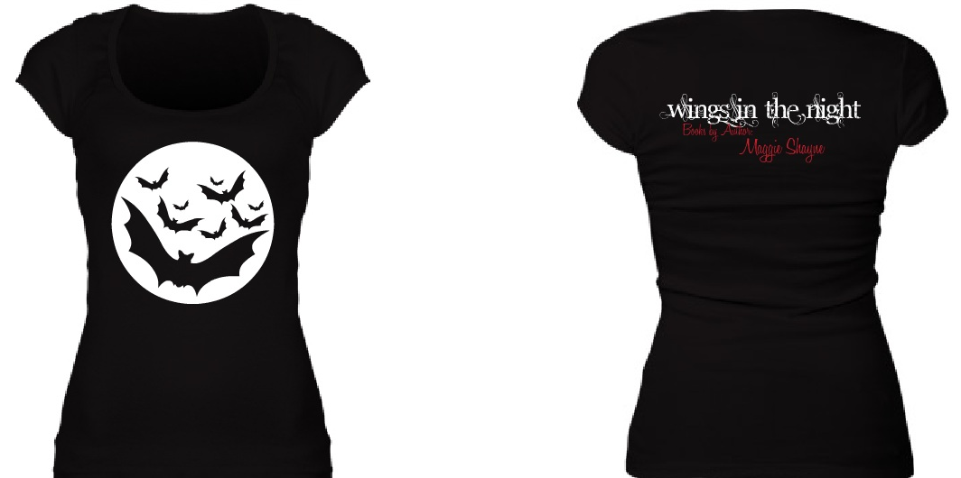
Wings in the Night Scoopneck tee

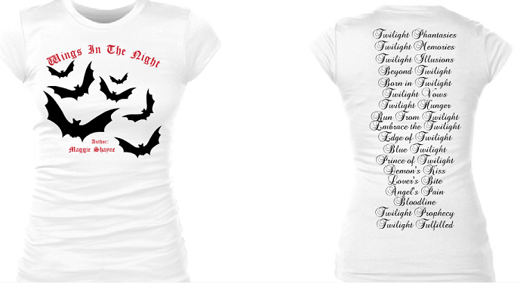
Wings in the Night Book List Tee
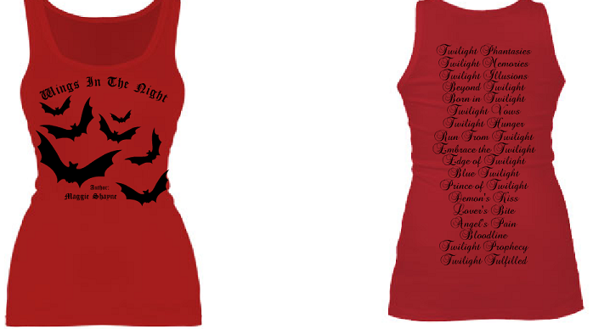
Wings in the Night Book List Tank
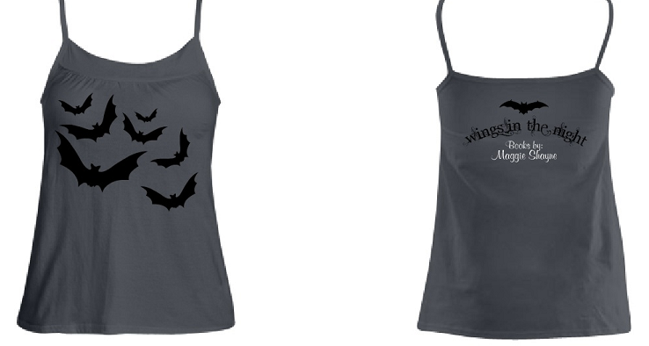
Wings in the Night Babydoll Cami (great for PJs)
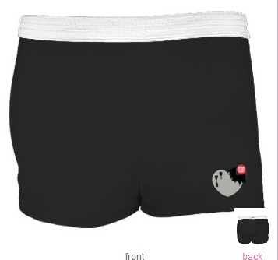
Vamp bitten heart and Wings in the Night bat shorts (great for PJs)
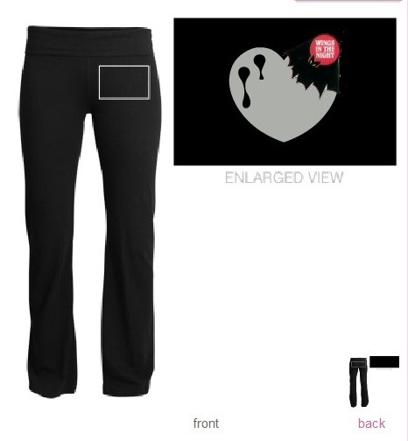
Vamp bitten heart and Wings in the Night bat Yoga pants
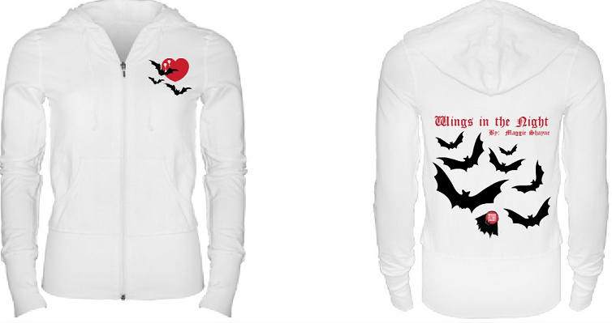
Wings in the night Hoodie
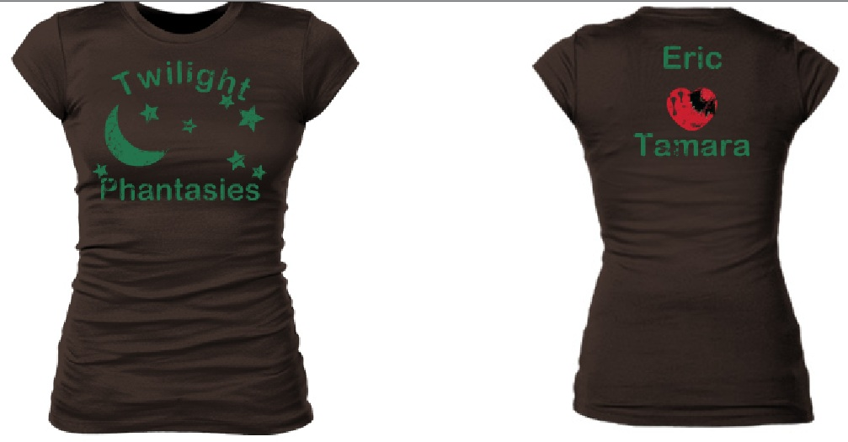 Distressed Twilight Phantasies, Eric and Tamara tee. Colors match the book. Vamp bitten heart with Wings in the Night bat.
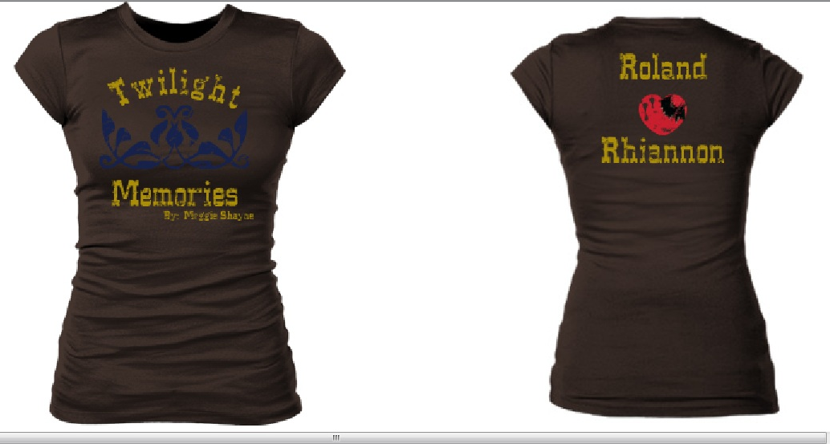
Distressed Twilight Memories, Roland and Rhiannon tee. Colors match the book. Vamp bitten heart with Wings in the Night bat.
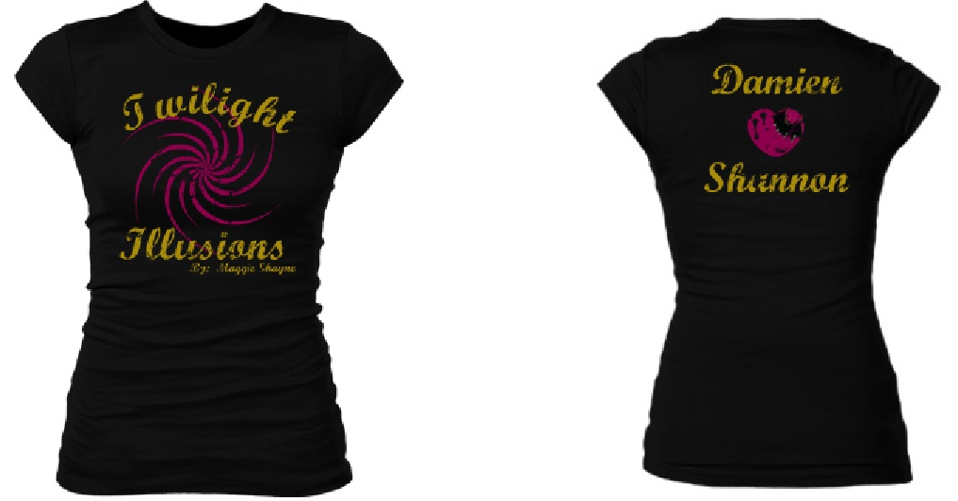
Distressed Twilight Illusions, Damien and Shannon tee. Colors match the book. Vamp bitten heart with Wings in the Night bat.
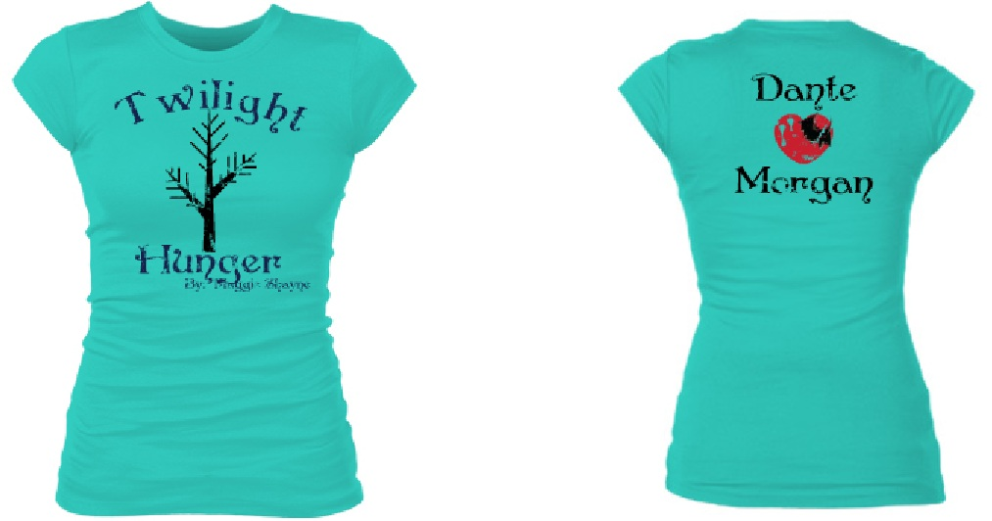
Distressed Twilight Hunger, Dante and Morgan tee. Colors match the book. Vamp bitten heart with Wings in the Night bat.
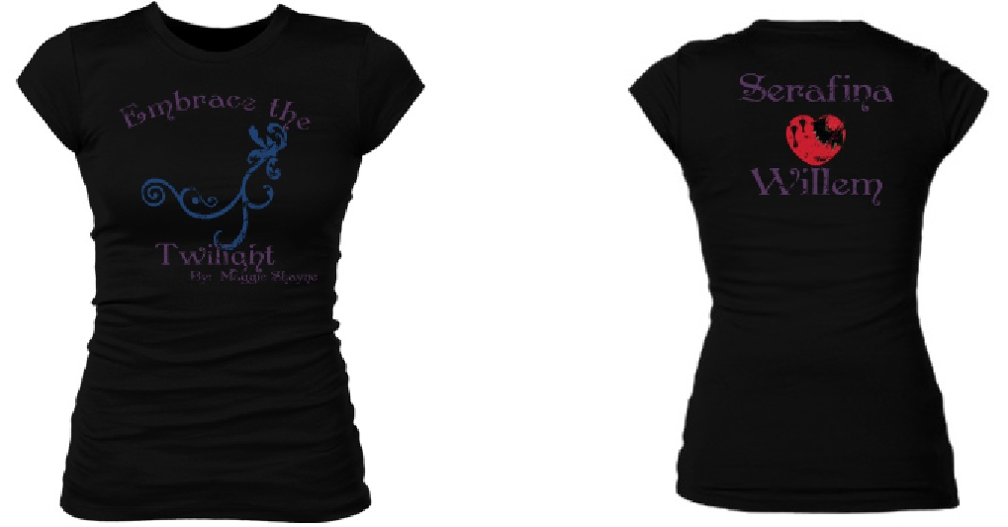
Distressed Embrace the Twilight, Serafina and Willem tee. Colors match the book. Vamp bitten heart with Wings in the Night bat.
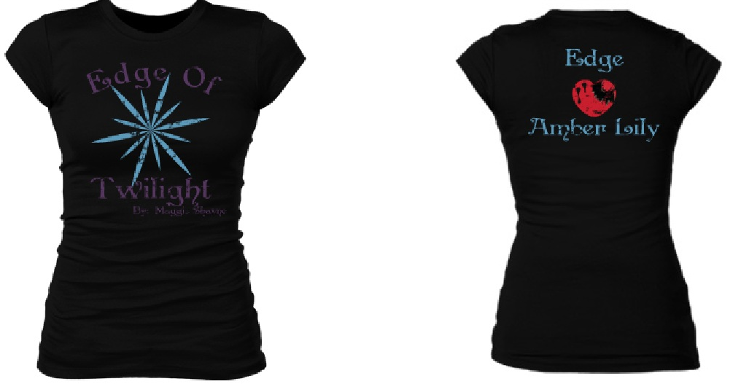
Distressed Edge of Twilight, Edge and Amber Lily tee. Colors match the book. Vamp bitten heart with Wings in the Night bat.
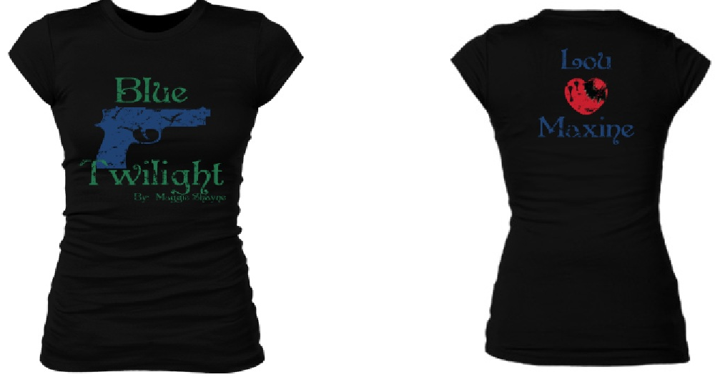
Distressed Blue Twilight, Lou and Maxine tee. Colors match the book. Vamp bitten heart with Wings in the Night bat.
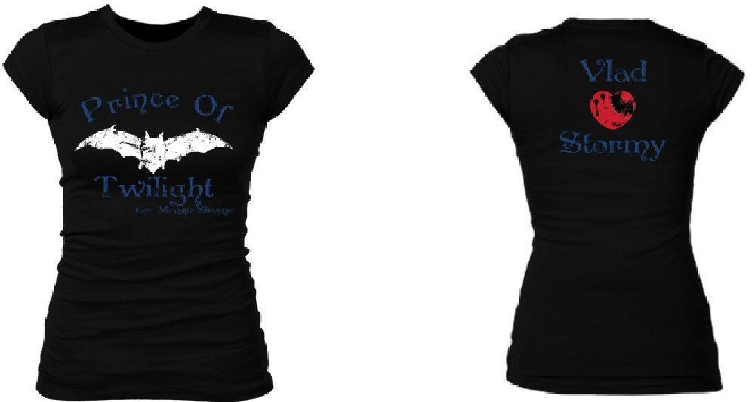
Distressed Prince of Twilight, Vlad and Stormy tee. Colors match the book. Vamp bitten heart with Wings in the Night bat.

