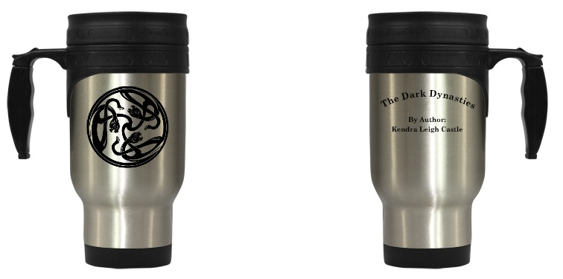

Cait Sith Travel mug

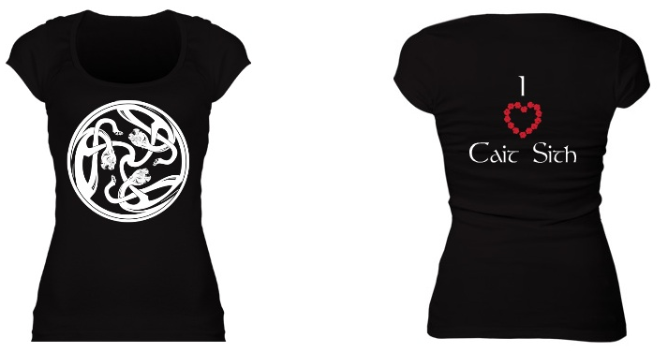

I <3 Cait Sith Fitted Scoopneck Tee

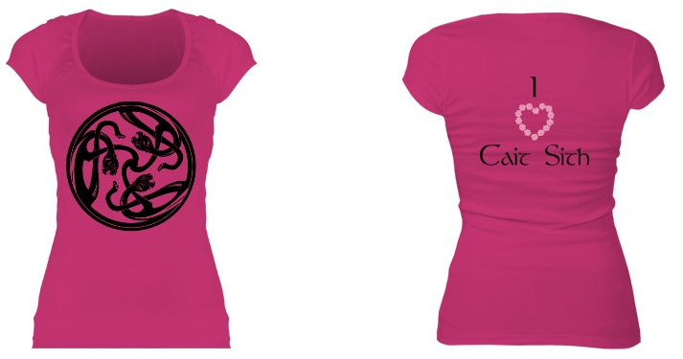

I <3 Cait Sith Fitted Scoopneck tee in girly pink

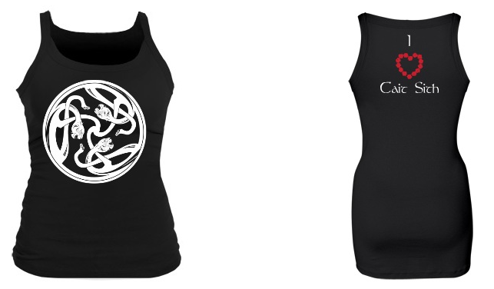

I <3 Cait Sith strappy longer length fitted tank

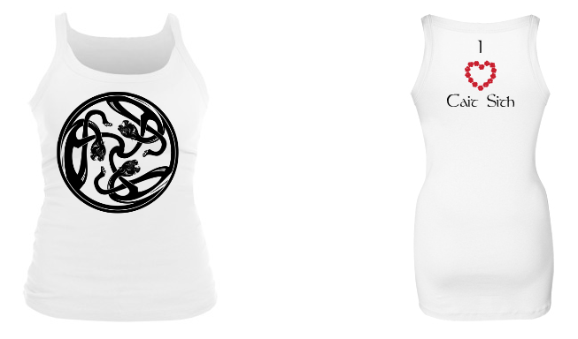

I <3 Cait Sith strappy longer length fitted tank in white

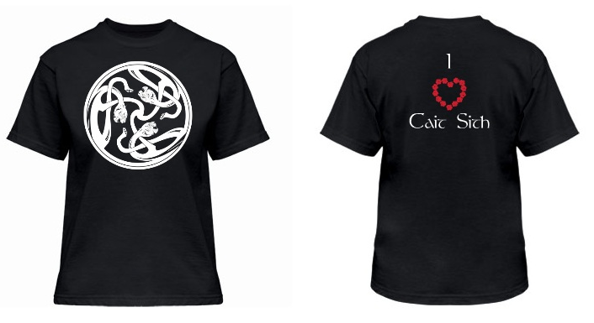

I <3 Cait Sith Relaxed Tee

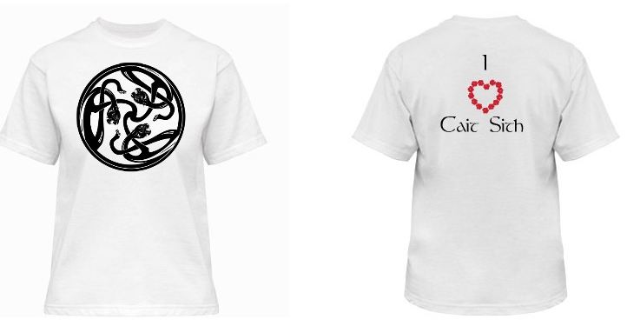

I <3 Cait Sith Relaxed Tee in White

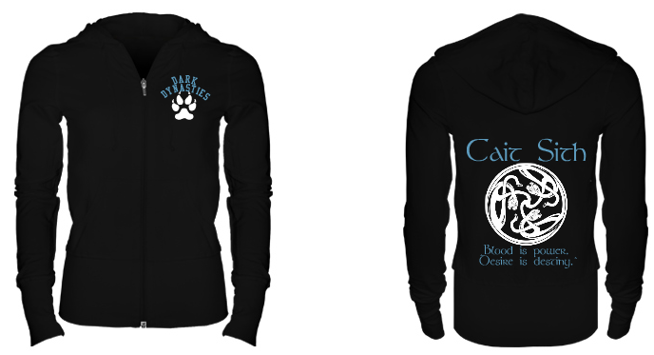

Cait Sith Hoodie

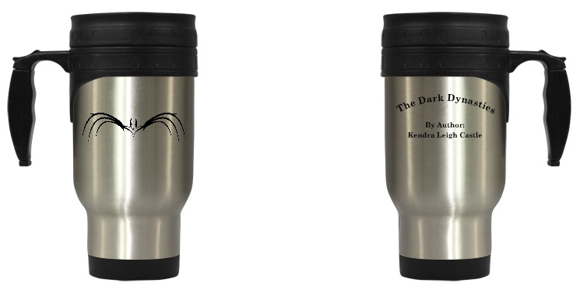

Dracul Travel Mug

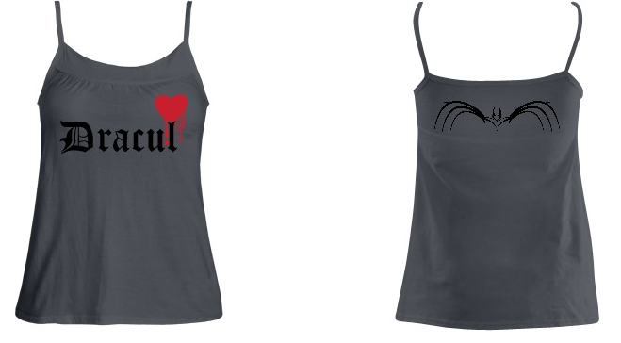

Dracul babydoll cami

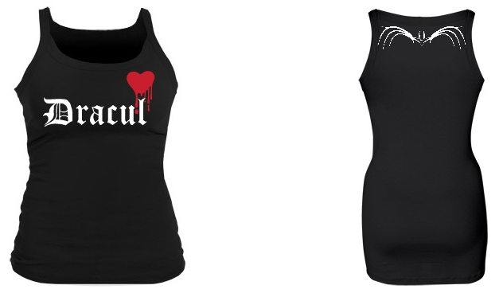

Dracul strappy longer length fitted tank

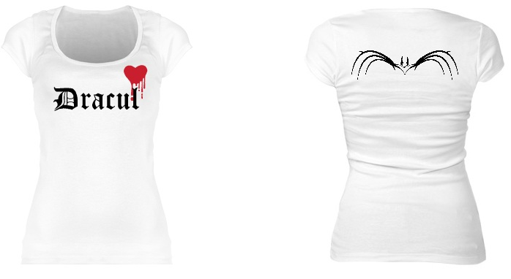

Dracul scoopneck fitted tee in white

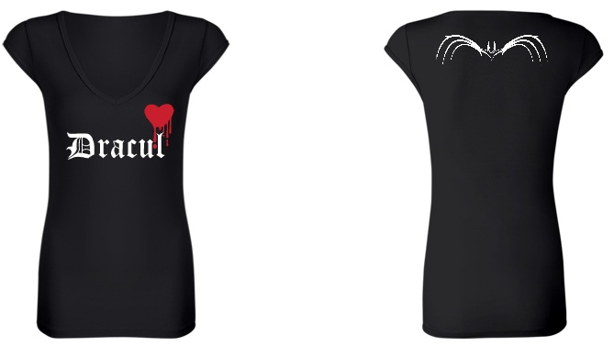

Dracul fitted black Vneck

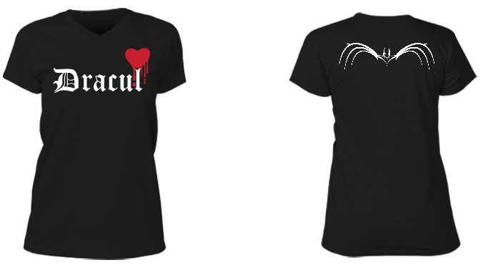

Dracul relaxed vneck

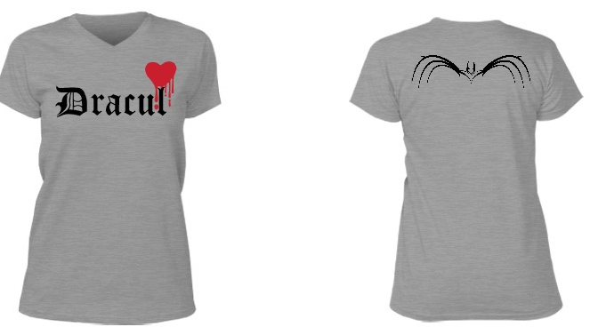

Dracul relaxed vneck tee in heather gray

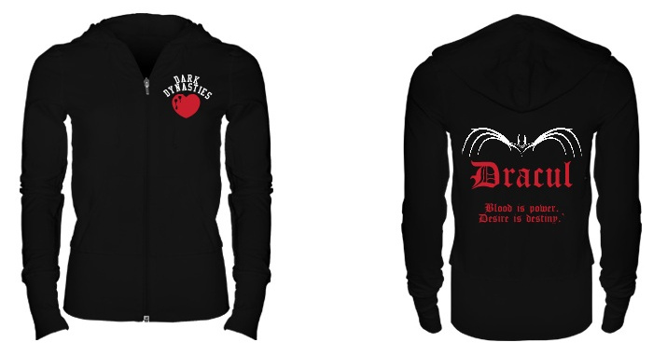

Dracul Hoodie

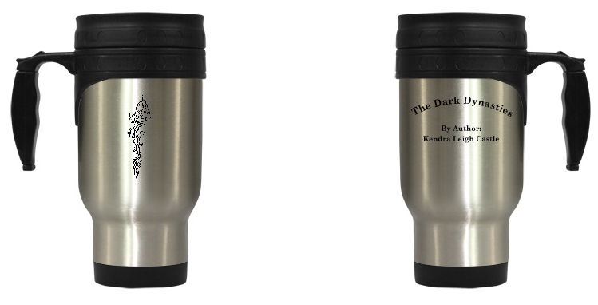

Empusae Travel mug

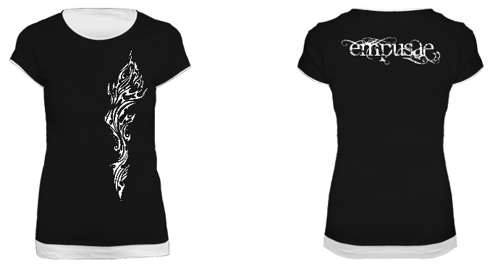

Empusae fitted layered look tee

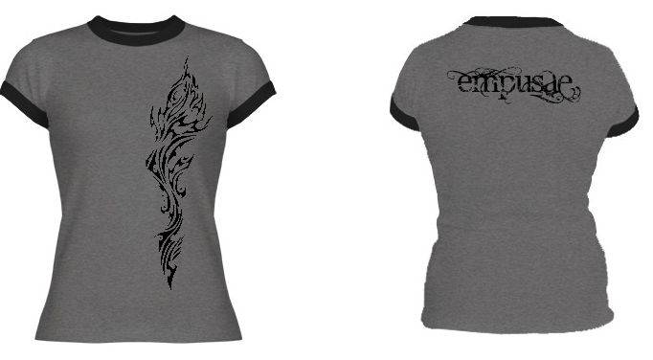

Empusae Ringer tee

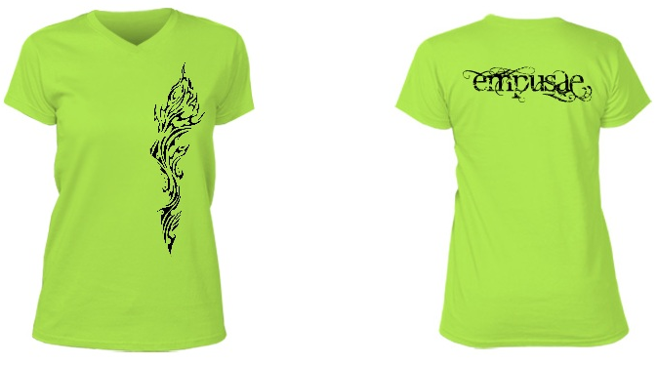

Empusae bright relaxed vneck tee

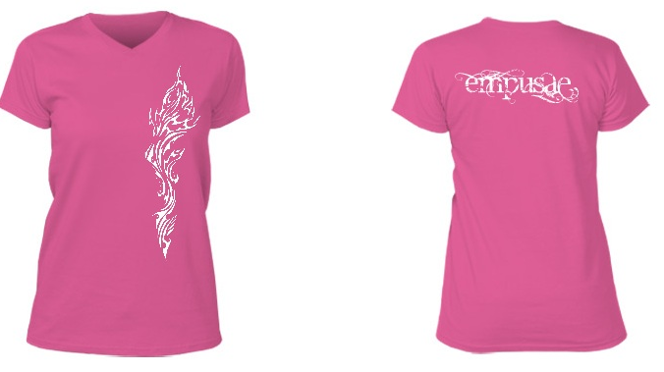

Empusae girly relaxed vneck tee

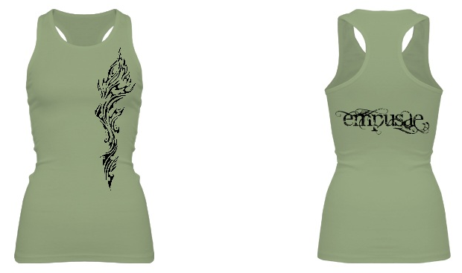

Empusae fitted longer length racerback tank

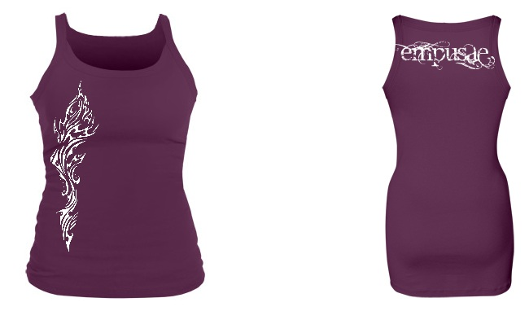

Empusae Strappy fitted longer length tank

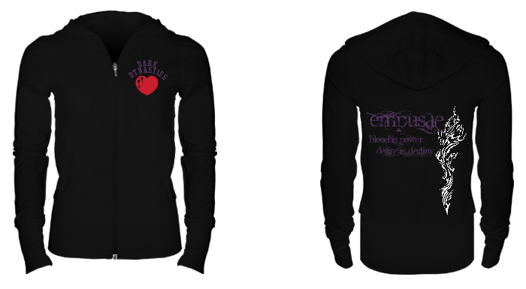

Empusae hoodie

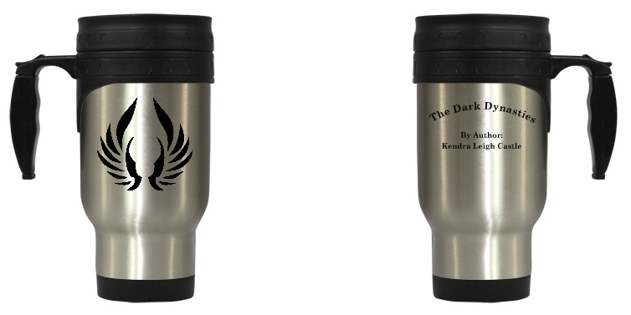

Grigori Travel Mug

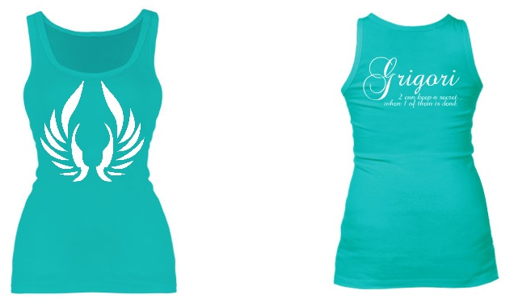

Grigori girly color longer length fitted tank

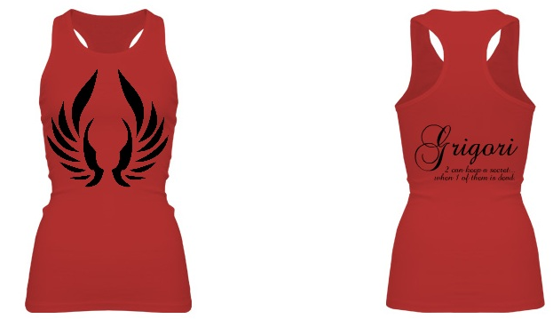

Grigori longer length racerback fitted tank

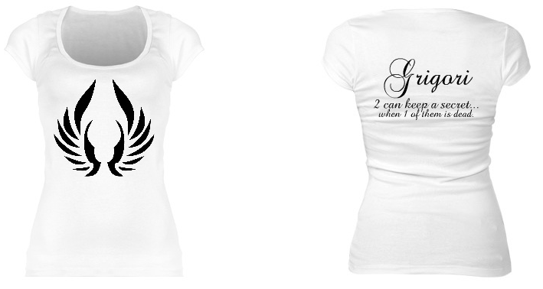

Grigori scoopneck fitted tee

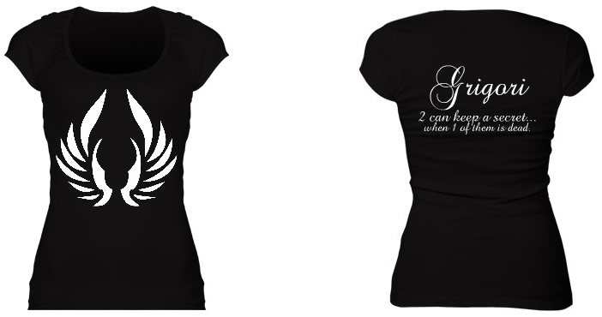

Grigori fitted schoopneck black

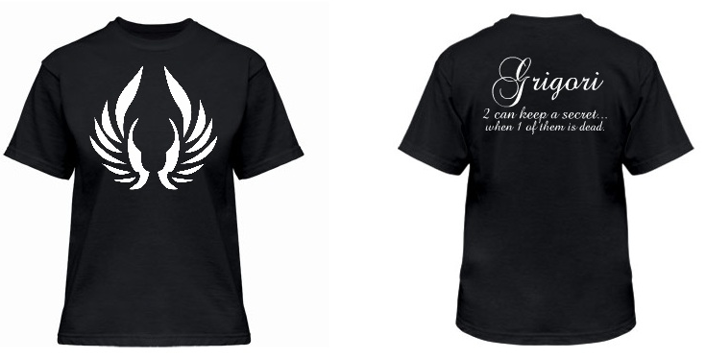

Grigori relaxed fit tee

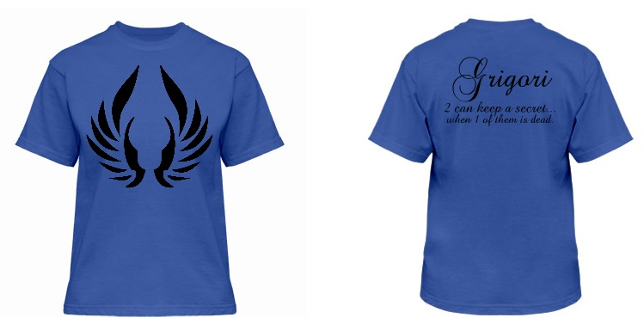

Grigori relaxed fit tee in brighter color

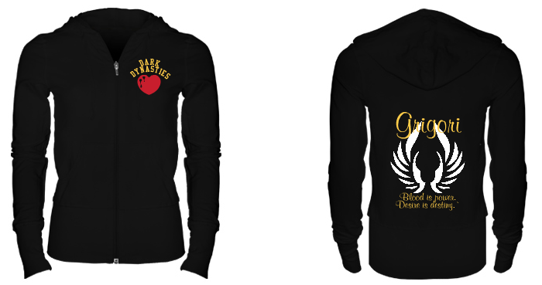

Grigori Hoodie

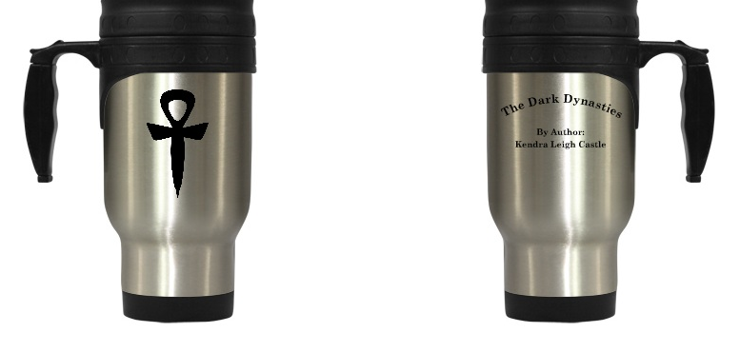

Ptolemy Travel Mug

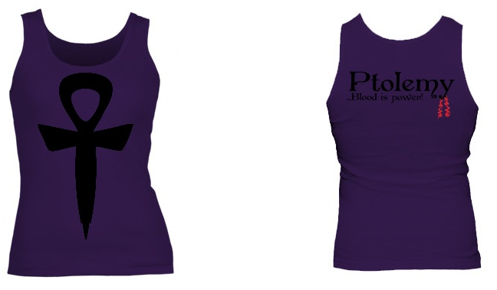

Ptolemy fitted class tank

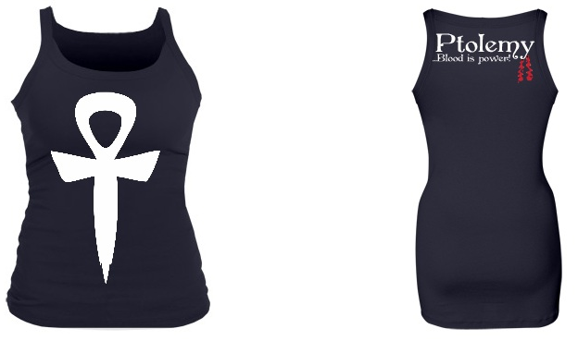

Ptolemy strappy longer length fitted tank

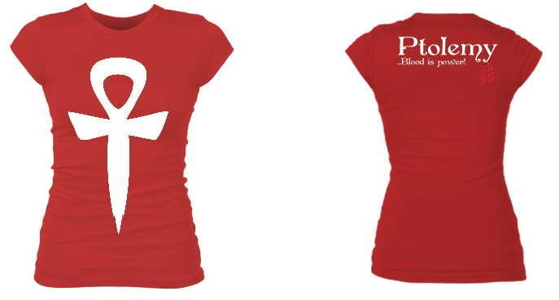

Ptolemy fitted longer length crew tee

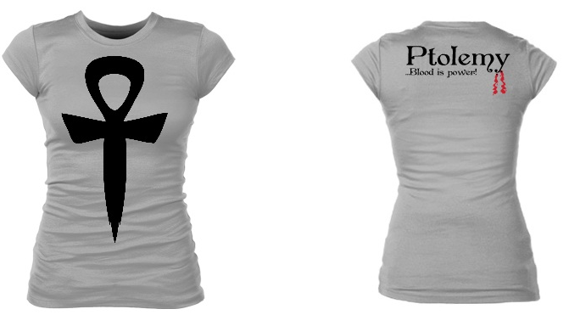

Ptolemy fitted longer length crew tee in gray

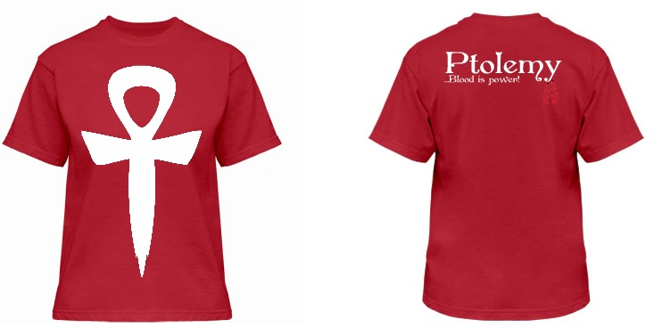

Ptolemy relaxed fit tee

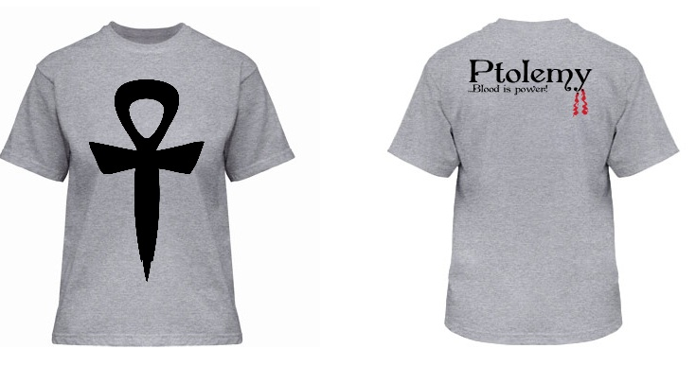

Ptolemy relaxed fit tee in heather gray

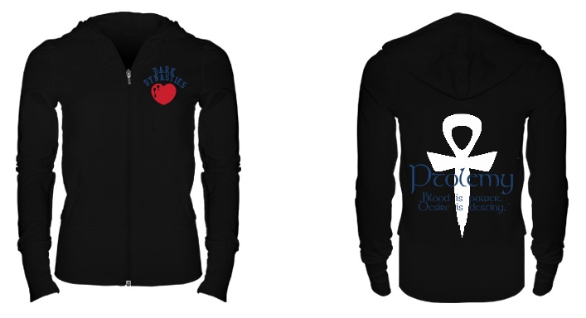

Ptolemy Hoodie